

#### Module (Bootstrap Basic & Advanced) – 6

1. What are the advantages of Bootstrap?

Bootstrap is a popular open-source front-end framework that simplifies the process of designing and building responsive and mobile-first web pages. Here are some advantages of using Bootstrap:

1. ***Responsive Design:*** Bootstrap is built with a mobile-first approach, making it easy to create responsive designs that work well on various devices and screen sizes. It provides a grid system and responsive utilities for creating flexible layouts.
2. ***Consistency:*** Bootstrap offers a consistent and standardized set of styles and components, which helps maintain a cohesive and professional look across different sections of a website or web application. This consistency can save time and effort in the design and development process.
3. ***Cross-browser Compatibility:*** Bootstrap is designed to be compatible with major web browsers, ensuring that your website or application looks and functions consistently across different browsers.
4. ***Time-saving:*** Bootstrap comes with a pre-built set of CSS and JavaScript components, such as navigation bars, buttons, forms, and more. This reduces the need to write custom code for common elements, saving development time.
5. ***Customizable:*** While Bootstrap provides a default set of styles and components, it is highly customizable. Developers can easily customize the framework to match the specific design requirements of their project. There are also themes and templates available to further speed up the customization process.
6. ***Community and Documentation:*** Bootstrap has a large and active community of developers. This means there are plenty of resources, tutorials, and forums available for support. The official documentation is comprehensive, making it easy for developers to learn and use Bootstrap effectively.
7. ***Integration with JavaScript Libraries:*** Bootstrap seamlessly integrates with popular JavaScript libraries like jQuery. This makes it easy to enhance the functionality of your website or application by incorporating additional interactive elements.
8. ***Extensive Component Library:*** Bootstrap provides a rich set of UI components, such as navigation bars, modals, carousels, and more. These components are ready-to-use and can be easily customized, saving developers from having to build them from scratch.
9. ***Accessibility:*** Bootstrap follows best practices for web accessibility, ensuring that websites and applications built with Bootstrap are usable by people with disabilities. This is important for creating inclusive and accessible digital experiences.
10. ***Regular Updates:*** Bootstrap is actively maintained and updated, which means that developers can benefit from the latest features, bug fixes, and improvements. Regular updates also help ensure compatibility with the latest web standards and technologies.
11. What is a Bootstrap Container, and how does it work?

In Bootstrap, a container is a fundamental layout element used to wrap and contain the content of a web page. It is part of the grid system provided by Bootstrap and plays a crucial role in creating responsive and organized layouts. The container class is used to establish a fixed-width container within the page, helping to control the layout and alignment of content.

There are two types of containers in Bootstrap: the .container class and the .container-fluid class.

1. ***container:***

* The .container class creates a fixed-width container that adjusts its width based on the user's screen size. It is designed to be used for responsive layouts.
* The container has a predefined maximum width for different screen sizes, making it easy to create consistent and visually appealing designs.
* It adds padding to the left and right sides, ensuring that content does not reach the edges of the screen.

Example:



1. ***container-fluid:***

* The .container-fluid class creates a full-width container that spans the entire width of the viewport.
* Unlike the .container class, it does not have a fixed maximum width, and it adjusts its size fluidly as the screen size changes.
* It also adds padding to the left and right sides, similar to the .container class.

Example:



***How it works:***

* When you use a container, it helps in organizing and structuring your content within a defined space, making it more readable and visually appealing.
* The container plays a crucial role in conjunction with the Bootstrap grid system. Rows and columns are placed inside containers to create a flexible and responsive layout. The grid system allows you to divide the container into a series of rows and columns, determining the placement of various elements on the page.
* By default, Bootstrap provides a responsive grid system with 12 columns. The width of these columns adjusts based on the width of the container, providing flexibility in designing layouts for different screen sizes.
* Containers ensure that the content remains within a specified width range, preventing it from stretching too wide on larger screens or becoming too cramped on smaller screens.

In summary, Bootstrap containers are essential for creating responsive and organized layouts, and they work in conjunction with the grid system to structure content within a specified space on a web page.

1. What are the default Bootstrap text settings?

Bootstrap provides a set of utility classes for manipulating text elements. These classes can be used to control various aspects of text, such as font size, font weight, alignment, and more. Here are some of the default Bootstrap text-related utility classes:

1. ***Font Size:***

* ***.text-xs:*** Extra small text.
* ***.text-sm:*** Small text.
* ***.text-md:*** Medium-sized text (default size).
* ***.text-lg:*** Large text.
* ***.text-xl:*** Extra-large text.
* ***.text-2xl, .text-3xl, ... :*** Additional classes for larger text sizes.

Example:



1. ***Font Weight:***

* ***.font-weight-bold:*** Sets the text to bold.
* ***.font-weight-normal:*** Resets the font weight to the default (normal).

Example:



1. ***Text Alignment:***

* ***.text-left:*** Aligns text to the left.
* ***.text-center:*** Centers text.
* ***.text-right:*** Aligns text to the right.
* ***.text-justify:*** Justifies text.

Example:



1. ***Text Color:***

* ***.text-primary, .text-secondary, .text-success, ... :*** Classes for setting text color based on Bootstrap's color scheme.
* ***.text-light, .text-dark:*** Light and dark text colors.

Example:



1. ***Text Transformation:***

* ***.text-uppercase:*** Converts text to uppercase.
* ***.text-lowercase:*** Converts text to lowercase.
* ***.text-capitalize:*** Capitalizes the first letter of each word.

Example:



1. What do you know about the Bootstrap Grid System?

The Bootstrap Grid System is a responsive, mobile-first grid system that facilitates the creation of complex layouts with a consistent and flexible structure. It is a key component of the Bootstrap front-end framework and is based on a 12-column layout.

***Rows****:*

Inside the container, rows are created using the <div class="row"> element. Rows act as horizontal containers for columns.

***Columns****:*

Columns are placed inside rows and are defined using classes such as .col-sm, .col-md, and so on. The number after "col-" represents the number of columns the element should span out of the total 12 columns available in the grid.

***Responsive******Classes****:*

Bootstrap provides responsive classes to control the layout at different breakpoints. For example, .col-sm-6 will make the column take 6 out of 12 columns on small screens and larger.

1. What is the difference between Bootstrap 4 and Bootstrap 5

There were several key differences between Bootstrap 4 and Bootstrap 5. Here are some of the notable differences between Bootstrap 4 and Bootstrap 5:

1. ***Dropped jQuery Dependency:***

One significant change in Bootstrap 5 is the removal of the dependency on jQuery for JavaScript components. Bootstrap 5 encourages the use of modern JavaScript, such as vanilla JavaScript or a JavaScript framework like Vue.js or React.

1. ***Customizable and Lighter:***

Bootstrap 5 is designed to be more modular and customizable. It allows developers to pick and choose the components they need, resulting in a lighter and more efficient framework. This approach contrasts with Bootstrap 4, which included a more monolithic set of components.

1. ***New Utility Classes:***

Bootstrap 5 introduced new utility classes for spacing, typography, and color manipulation. These classes provide more flexibility and control over the appearance of elements.

1. ***Improved Grid System:***

While the overall grid system structure remains similar, Bootstrap 5 introduced improvements such as a new grid tier (xxl) for even larger screens, enhanced gutter classes, and a more consistent spacing system.

1. ***Updated Forms and Components:***

Bootstrap 5 includes updates to forms and components, providing new styles and options for customization.

1. ***Removal of Card Decks:***

Bootstrap 5 removed the card-deck class, and developers are encouraged to use the grid system for creating card layouts instead.

1. ***New Logo and Branding:***

Bootstrap 5 introduced a new logo and branding to give the framework a fresh and modern look.

1. ***Documentation Improvements:***

The documentation for Bootstrap 5 has been improved and refined, making it more user-friendly and providing better guidance for developers.

1. What is a Button Group, and what is the class for a basic Button Group?

In Bootstrap, a button group is a group of buttons that are visually grouped together. Button groups are useful for presenting related actions or options in a compact and organized manner. They can be styled to appear as a cohesive unit, and different styles can be applied to create segmented button groups.

The basic class for a button group in Bootstrap is .btn-group. This class is used to wrap a set of button elements to create a button group. There are variations of button groups, including segmented button groups and button toolbars.

Here's an example of a basic button group:

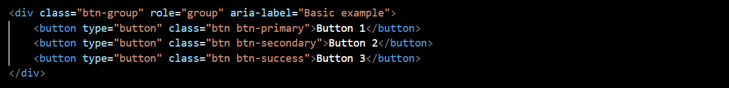

In this example:

* The btn-group class is applied to the <div> element, indicating that it is a button group.
* The role="group" attribute is used for better accessibility, indicating that the div serves as a group of buttons.
* The aria-label="Basic example" attribute provides a label for assistive technologies, describing the purpose of the button group.

Button groups can be further customized using additional classes and options, such as:

* .btn-group-lg for a large-sized button group.
* .btn-group-sm for a small-sized button group.
* .btn-group-vertical for a vertically stacked button group.
* Various spacing and sizing classes for fine-tuning the appearance.

Here's an example of a vertically stacked button group:

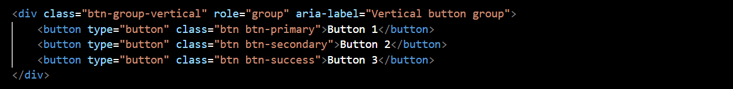

Button groups provide a convenient way to organize and style related buttons in your user interface.

1. How can you use Bootstrap to make thumbnails?

In Bootstrap, you can create thumbnails using the .card component to wrap images or other content. Thumbnails are small, bordered containers that can contain images, text, or other media. Here's a basic example of how to use Bootstrap to create thumbnails:

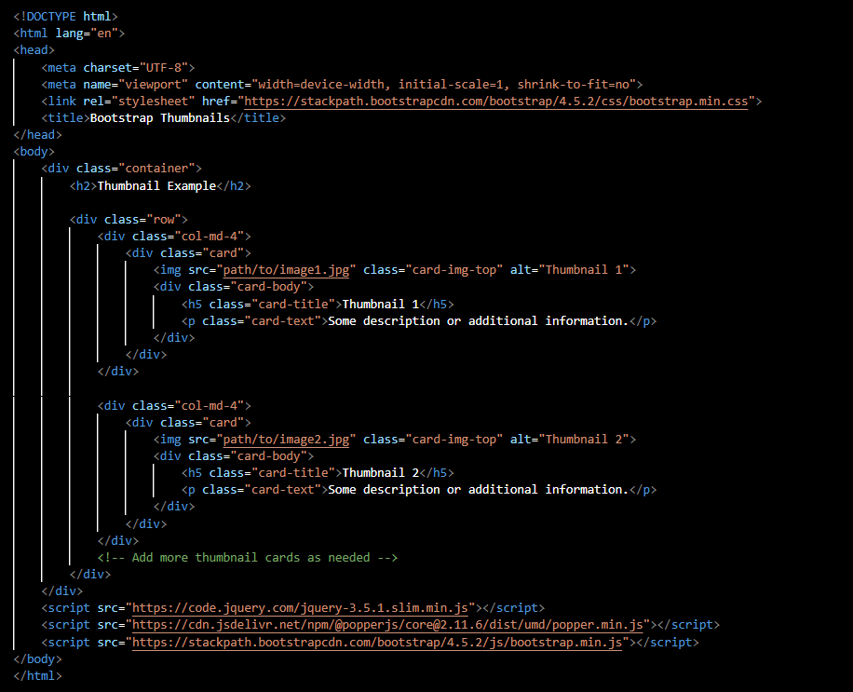

In this example:

1. The Bootstrap CSS and JavaScript files are included from a CDN for styling and functionality.
2. The container class is used to create a responsive fixed-width container.
3. Inside the container, a row class is used to create a horizontal grouping of thumbnail cards.
4. Each thumbnail is created using the .card class.
5. The .card-img-top class is used to position the image at the top of the card.
6. The .card-body class is used for the body of the card, where you can include the title (card-title) and text (card-text) for the thumbnail.
7. In Bootstrap 4, what is flexbox?

In Bootstrap 4, the Flexbox (Flexible Box Layout) model is a powerful layout system used for designing responsive and flexible web pages. Flexbox provides a more efficient and predictable way to arrange, distribute, and align items within a container, even when the size of the items or the container is unknown or dynamic.

Flexbox is implemented in Bootstrap 4 to create the grid system, which is used for building responsive and flexible layouts. Here are key concepts related to Flexbox in Bootstrap 4:

1. ***Flex Container:***

* The parent element containing one or more flex items is known as the flex container.
* In Bootstrap 4, the .d-flex class is used to make an element a flex container. This class can be applied to various HTML elements such as <div>, <ul>, or <nav>.

Example:



1. ***Flex Items:***

* The child elements of a flex container are referred to as flex items.
* By default, flex items are laid out in a row, but you can change this direction using additional utility classes.
* Bootstrap provides classes like .flex-row, .flex-column, .flex-row-reverse, and .flex-column-reverse for changing the direction of the flex items.

Example:



1. ***Flex Alignment:***

* Flexbox allows you to easily align flex items both horizontally and vertically.
* Bootstrap provides utility classes like .justify-content-* for horizontal alignment and .align-items-* for vertical alignment. Replace * with values like start, end, center, between, and around for different alignment options.

Example:



1. ***Flex Order:***

* You can control the order of flex items using the .order-* utility class. Lower values for * will bring the item to the beginning, while higher values will move it toward the end.

Example:

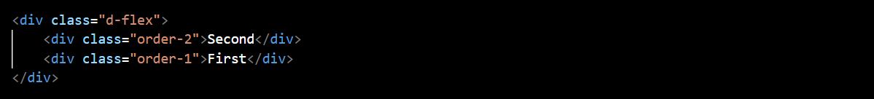

1. ***Responsive Flex Utility Classes:***

* Bootstrap provides responsive utility classes for applying Flexbox properties based on screen size.
* For example, you can use classes like .d-sm-flex to apply Flexbox for small screens and larger.

Example:



The use of Flexbox in Bootstrap 4 simplifies the creation of flexible and responsive layouts, making it easier to adapt to different screen sizes and device orientations. The combination of the grid system and Flexbox provides a powerful and versatile approach to web layout design.

1. How can one create an alert in Bootstrap?

In Bootstrap, we can create alerts using the .alert class along with contextual classes to define the appearance and color of the alert. Alerts are useful for displaying important messages or information to the user. Here's a basic example of how to create an alert in Bootstrap:

In this example:

1. The Bootstrap CSS and JavaScript files are included from a CDN for styling and functionality.
2. The .alert class is used to create the basic structure of the alert.
3. Contextual classes like .alert-primary, .alert-secondary, etc., are used to define the color and style of the alert. Choose the class that corresponds to the desired visual style.
4. The role="alert" attribute is added for accessibility purposes, indicating that the element serves an alert role.

We can customize the content and appearance of the alert based on your specific requirements. Additionally, Bootstrap provides dismissible alerts, which include a close button for users to dismiss the alert. To create a dismissible alert, add the .alert-dismissible class and a close button inside the alert.

1. What is a bootstrap card and how would you create one?

In Bootstrap, a card is a flexible and extensible container that can contain various types of content, including images, text, links, and more. Cards are a versatile component used to display information in a structured and visually appealing way. They are commonly used for presenting content like articles, blog posts, user profiles, and product details.

I have attached separate file of card

below is screen shot of the same

